**Project Details**

|  |  |
| --- | --- |
| Project number | *19* |
| Project title | *Mega Store Corporation* |
| Corresponding TA\LA | *Dina Abbas* |
| Deliverable | *1* |

**Team Details**

|  |  |  |
| --- | --- | --- |
| **Student ID** | **Student name** | **Lab Group** |
| 20200629 | يارا محمد سعد محمد | S5 |
| 20200165 | حنين محمد عويس | S7 |
| 20201102 | شيرين شوقى حسن أحمد | S5 |
| 20201183 | ميار محمد حامد عبدالمجيد | S8 |
| 20200595 | ندين بدر الدين عبد العاطى | S8 |
| 20200387 | كاريمان أيمن عبداللطيف | S8 |
| 20200732 | ياسمين سامى عبد القوى | S8 |

**Phase 3: DESIGN THE ENVIRONMENT and THE USER & SYSTEM INTERFACES**

**DESIGN THE ENVIRONMENT**

1. **Using the project description then answer the following questions:**
2. With what external systems and databases will the system under development interact?

* **External Systems:**

Payment systems , Warehousing and logistic systems , Customer relationship management systems , Web services , Marketing and advertising platforms , Social media platforms.

* **Databases:**

**Tables Names :** Customer , Products , Product categories , Orders , Order items , Inventory , Suppliers , Employee.

**Customer columns :** customer_id , first_name , last_name , phone_number , email.

**Products columns :** product_id , name , description , price , category.

**Product categories columns :** category_id , category_name.

**Orders columns :** order_id , customer_id , order_id , order_total.

**Order items columns :** order_item_id , order_id , product_id , quantity.

**Inventory columns :** product_id , quantity_on_hand , reorder_level.

**Suppliers columns :** supplier_id , name , contact_information.

**Employee columns :** employee_id , first_name , last_name , job_title.

1. What devices will be used for automated inputs and outputs?

**Devices:**

**Input devices :** Bar code scanners , Touchscreens , RFID scanners , Electronic cash registers , Keyboard.

**Output devices :**  Label printers , Receipt printers , Display screens , Printing devices.

1. What user-interface technology will be used?

**1.Where users will be located?**

Users can be located in various locations including the physical store , online through the store website or mobile application , and other locations as the corporation offers delivery services .

1. **What hardware devices will users use?**

Personal computers , Laptops , Tablets , Smart phones , Printers , Credit card terminals .

**THE USER & SYSTEM INTERFACES**

**3.Using the system sequence diagrams developed during the analysis phase of your project:**

1. Identify the various screens and forms that may be needed for the user interface.

**Note: Write all screens and forms for the previous 3 sequence diagrams**

-LIST OF USER INTERFACES (SCREENS/FORMS):

* Input Screen for determining item search name.
* Output Screen for viewing search items results.
* Input Screen for selecting options and adding it to the shopping cart.
* Input Screen for requesting a checkout.
* Output Screen to view the filled shopping cart.
* Output Screen to view the conformed checkout details.
* Input Screen for conforming the order.
* Input Screen for choosing payment method.
* Output Screen to view the payment methods details.
* Form for paying the pill depending on the selected payment method.
* Output Screen to view the completed payment details.
* Output Screen to view the user points details
* Input Screen for requesting a reusable bag.
* Output Screen to view the bag details.

**4.From use case diagrams developed during the analysis phase of your project which related to the screens and forms identified in (2.a):**

1. Create a good menu design by following the principles you studied. This should start by defining how use case are grouped inside a menu in a tabular format, which is followed by the actual menu design and define which menu style will be used?

**Note: Design your menu.**

|  |  |  |
| --- | --- | --- |
| Menu Description | Choices (Use Cases) | Intended Users |
| Items | 1. Add Item 2. Update Item 3. Remove Item 4. Provide Item 5. Search Items 6. View Items | * IT Personnel * Supplier * Customer |
| Offers | 1. Apply Offers 2. Apply Local Event Offer 3. Apply Global Event Offer | * IT Personnel |
| Return | 1. Return Item 2. Accept Return 3. Reject Return | * Customer * Logistics |
| Shopping Cart | 1. Fill Shopping Cart 2. Update Shopping Cart | * Customer |
| Payment | 1. Pay the Bill 2. Pay by Points 3. Pay by Cash 4. Pay by Credit Card 5. Verify Credit Card | * Customer * Bank System |
| Checkout | 1. Make Checkout 2. Ask for Reusable Bag 3. Gain Points | * Customer |

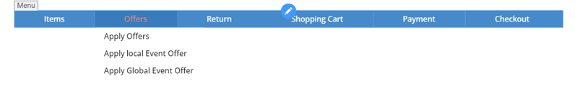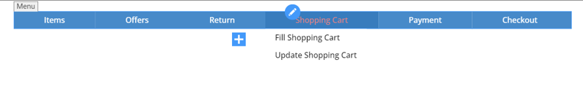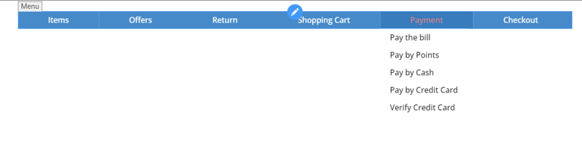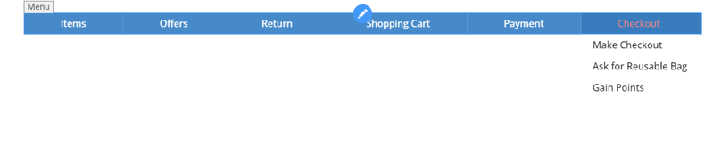

1. For the screens and forms identified in (2.a) create a **Storyboard** that captures the sequences of event. Storyboards may be designed using **wireframe tool or any low-fidelity** paper sketches, e.g. pencil tool, power points, etc.

**Note: Create one storyboard for one of the complex screens and forms**

Storyboard for payment by Credit Card and Cash.

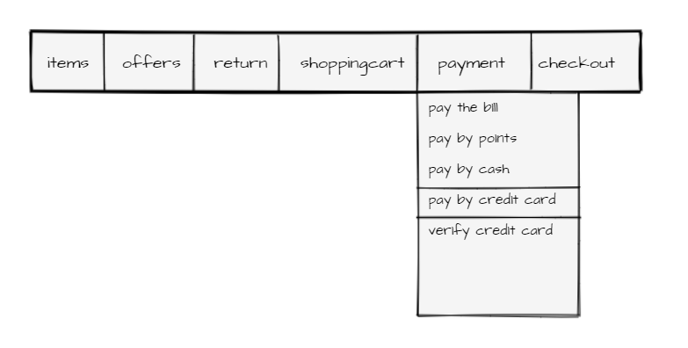

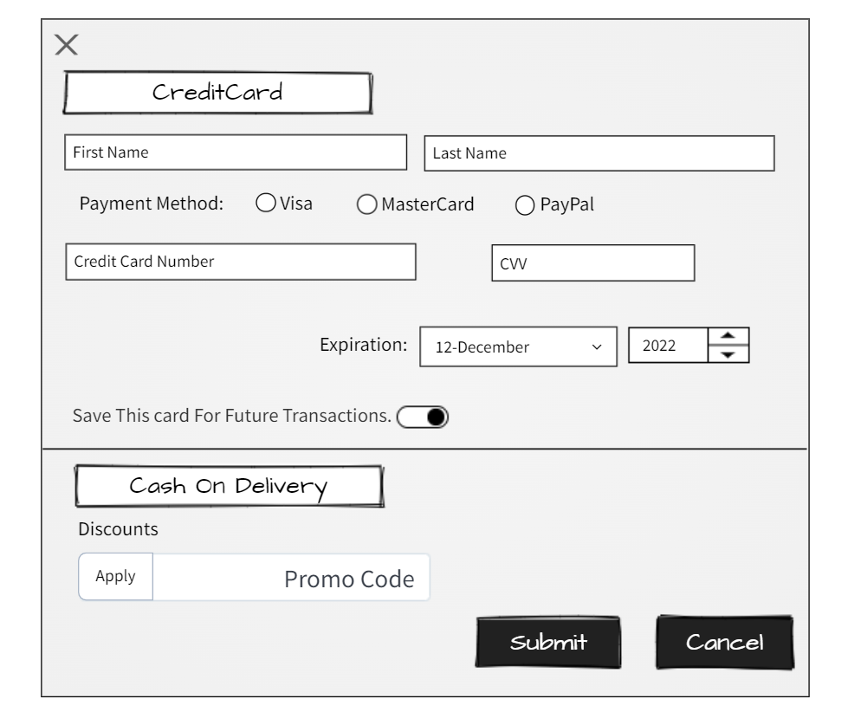

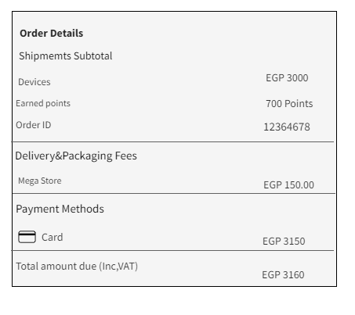

1. Design a web-based user interface (screen) and mobile/tablet interface for one of the screens from (2.a).

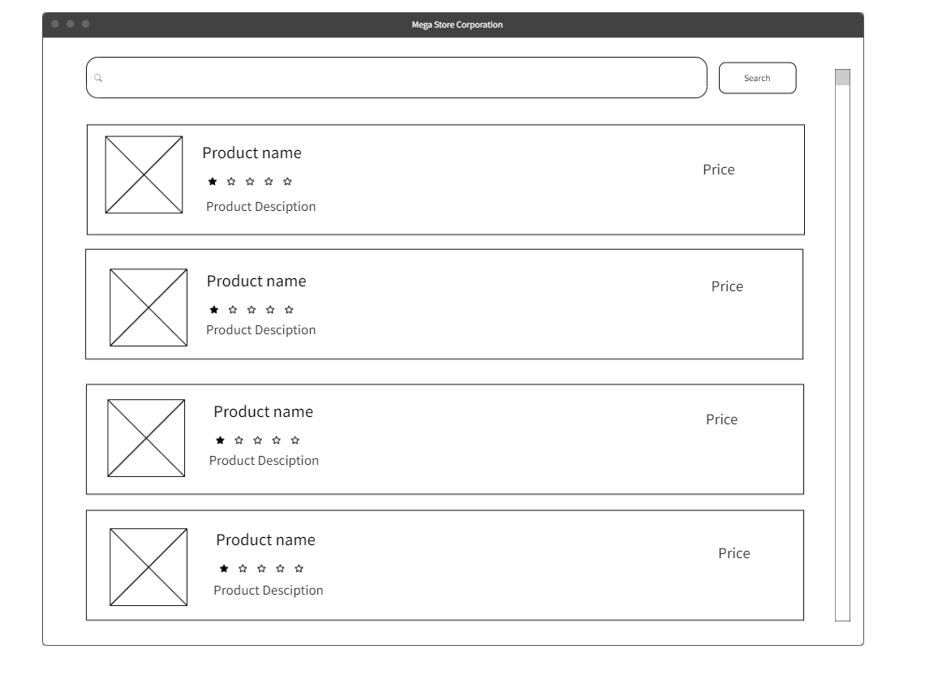

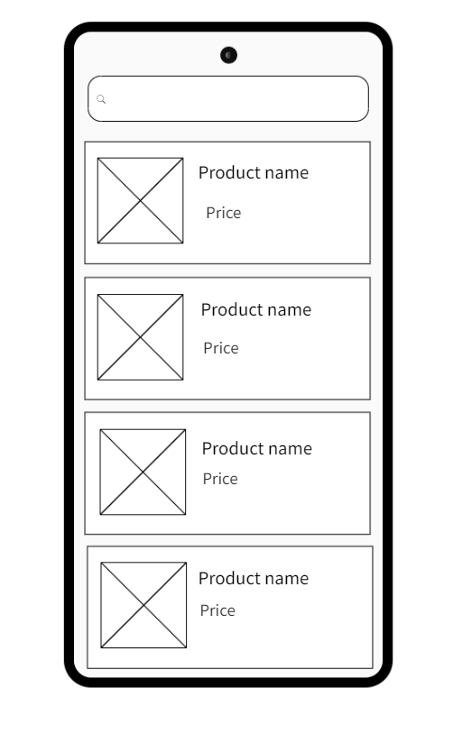

**5.Consider all User Interface Design Guidelines you studied and show how they addressed in your screens** Reports:

* **Design One electronic internal output reports of your choice:**

Products in Warehouse

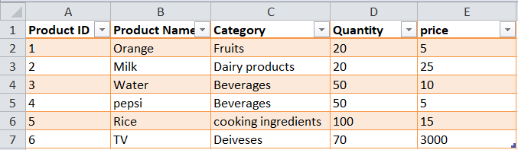

* **Design One electronic external output reports of your choice:**

Report generated to customer to check all his order

